**Wattpad Betta**

1. After typing date of birth there is no “enter” button. Instead there is a “настойки” buttom.

Steps:

* Download the app
* Open the app
* Click on buttom “register”
* Type in the fileds “name” , “surname” “date of birth” 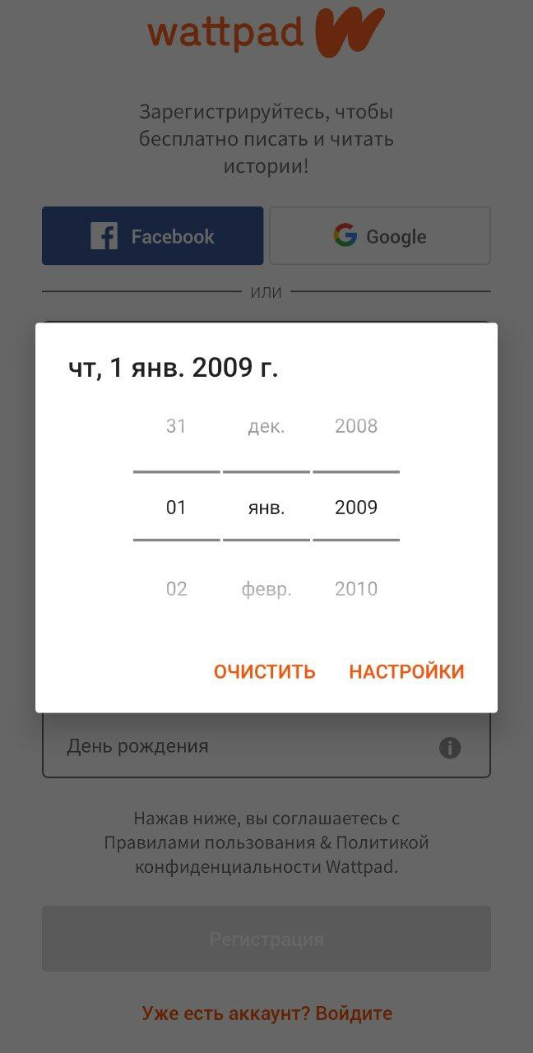

1. During reading, you can’t see your screen buttoms.

Steps:

* Download the app
* Open the app
* Click on buttom “register”
* Type in the fileds “name” , “surname” “date of birth”
* Choose genre of books
* Click on any book

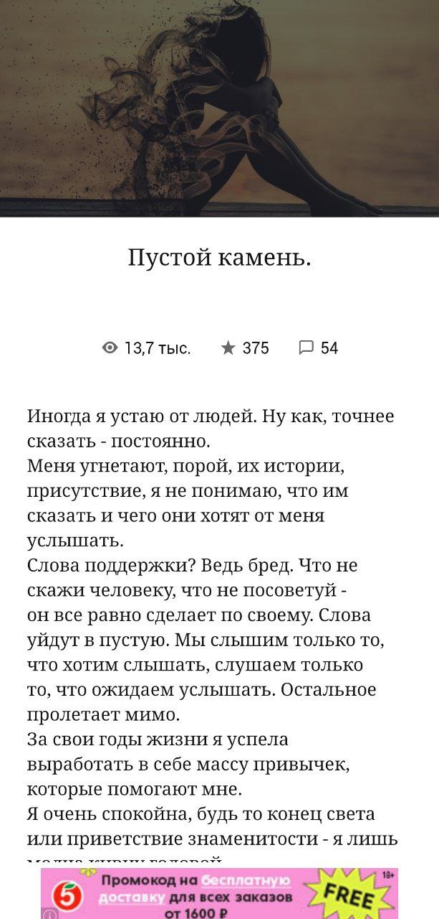

1. Notifications for messages arrive very late. During 5-7 minutes
2. Notifications in email arrive very late, even after reading message on app